









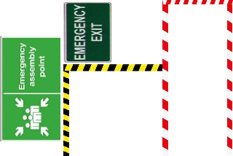
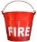






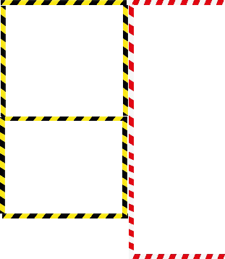


S
h
u Scrap Area
t
t e r
R/M Store (Beam , Column)

Machinary Area

Fabrication Area

R/M Store (sheet metal)

Drilling Area

Roof Fabrication Area

Maintenance Area

Store

Changing Room

Temple

Welding Gas Cylinder

Daily Prayer Area

Daily meeting area

Incoming Inspection Area

Cutting Area

Roof Assembly Area

Electrical Area

Paint Area

Washroom

Entry S
h
u t t e r
Exit

Loading & Unloading Area

Security Cabin

Finished Goods Area

Office Area

Assembly Area

Exhibition Area

Steel Door & Fire Rated Rollin g Shutt er

Sectional Door Area


Drinking
Area must required Clean
Hazardous Area
Area to be kept Clean and clear for Safety reasons
Area which present physical & health risk
Water

Colour Code Chart
Finished Goods Area, Manufacturing
Aisleway ,Gangways & Traffic lines
Material or Product Inspection
Office Area
Defect/Scrap Area
R/M, Store , Inventry Area
Restroom & Lavatory
Maintenance, Machine Storage

